# Media Analysis - Will ChatGPT and AI have an impact on Saudi workforce productivity_ _ Arab News

## Short Summary

The article discusses how ChatGPT and artificial intelligence AI will impact Saudi Arabia s workforce productivity, with insights from senior partner Raymond Khoury of Arthur D.

## Summary

Here are the key points from your text summarized into four bullet points:  
  
1. **Impact on workforce**: AI like ChatGPT can enhance productivity but may also replace some routine tasks, requiring employees to adapt.  
  
2. **Holistic approach**: Implementing AI successfully requires a strategic roadmap that defines objectives, advantages, and limitations.  
  
3. **Fostering learning environment**: To ensure a positive impact, organizations must create an environment that encourages continuous learning and improvement.  
  
4. **Leadership and agility**: Embedding AI into organizational operations calls for strong leadership, adaptability to change, and proactive planning.

## Question 1

The media, including the sample analyzed in this context i.e., discussions surrounding ChatGPT , plays a significant role in framing public discourse about a particular issue. In the case of ChatGPT, the media may use various metaphors to convey the concept, its implications, and how it fits into broader societal conversations. Some common metaphors that might emerge in public discussion about ChatGPT include 1. **Creative Tool** Comparing ChatGPT to a digital painting brush or music production software, highlighting its potential for enhancing human creativity. 2. ****Revolutionary Shift** Using the metaphor of a technological revolution akin to the Industrial Revolution , ChatGPT is portrayed as a game-changer that will fundamentally reshape various industries and job markets. 3. ****Boundary-Pushing Experiment** Comparing ChatGPT to an experimental scientific endeavor, emphasizing how its advanced AI capabilities may challenge conventional wisdom or uncover new insights. These metaphors are not exhaustive, but they illustrate the potential for media discourse on ChatGPT to frame the conversation around specific aspects of its functionality, implications, and societal impact.

## Question 2

The perspectives and aspects that are being widely covered in discussions about ChatGPT and AI s impact on Saudi workforce include 1. **Productivity and Efficiency** The potential for AI to increase productivity and efficiency through automation of mundane tasks. 2. **Job Replacement and Reskilling** Concerns over job displacement due to AI, emphasizing the importance of retraining and upskilling workers. 3. **Strategic Roadmap and Implementation** The process of integrating AI into organizations operations, including defining objectives, selecting appropriate tools, and adapting organizational structures. 4. **Workforce Development and Collaboration** The role of AI in fostering collaboration among team members, enabling access to tailored training programs, and enhancing overall workforce development. However, there are aspects that may be being overlooked or receiving less coverage 1. **Legal and Regulatory Framework** The lack of attention on the legal and regulatory challenges surrounding AI adoption, including privacy concerns and liability issues. 2. **Ethical Implications** Limited coverage on the ethical considerations surrounding AI implementation, such as algorithmic bias, social impact, and human-AI interaction. 3. **Cost-Benefit Analysis** A lack of in-depth analysis on the cost-benefit trade-offs associated with AI adoption for individual organizations or the broader workforce. 4. **Organizational Culture Change** The complexity of addressing cultural barriers to AI implementation within organizations, which may receive less attention than technical aspects.

## Question 3

Not mentioned. The article focuses on the impact of AI, specifically ChatGPT, on Saudi workforce productivity and global perspectives, but it doesn t explicitly mention the role of the Arabic World or their specific use of AI.

## Question 4

The final message is that successfully integrating AI into organizations operations requires strong leadership, adaptability, and proactive planning.

## Sentiment

The sentiment is 4.0

## Entities

Arthur D. Little, Saudi Arabias, Kasperskys, Khourys, AI, Embedding AI, Arthur D. Little, Arab News, Kingdoms, Khoury, Raymond Khoury, Kaspersky

## Highlights

#7cc867#fb5b89#f9cd59#c885da

## Wordcloud for #7cc867 Highlights

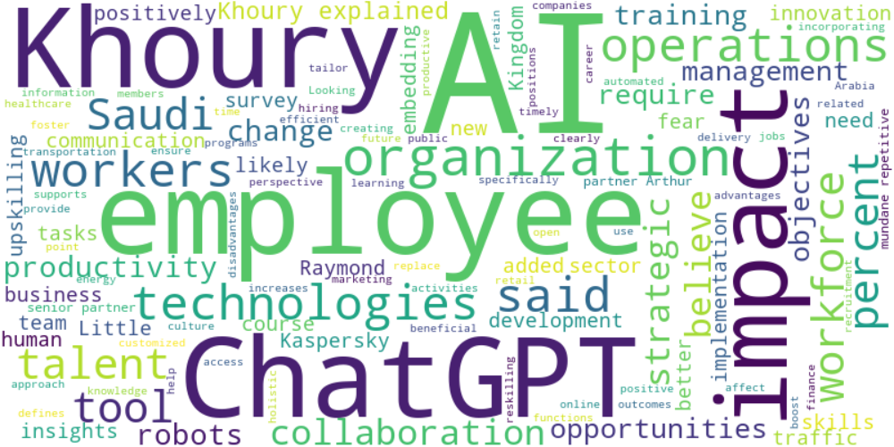

Top 10 words:

- AI: 35

- Khoury: 16

- ChatGPT: 12

- employees: 11

- impact: 9

- technologies: 6

- operations: 6

- said: 6

- workers: 6

- Saudi: 5

## Wordcloud for #fb5b89 Highlights

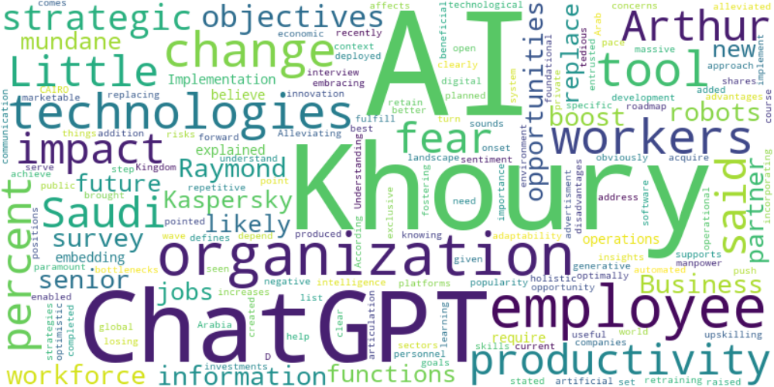

Top 10 words:

- AI: 14

- Khoury: 9

- ChatGPT: 6

- employees: 5

- technologies: 4

- workers: 4

- impact: 3

- Saudi: 3

- productivity: 3

- Arthur: 3

## Wordcloud for #f9cd59 Highlights

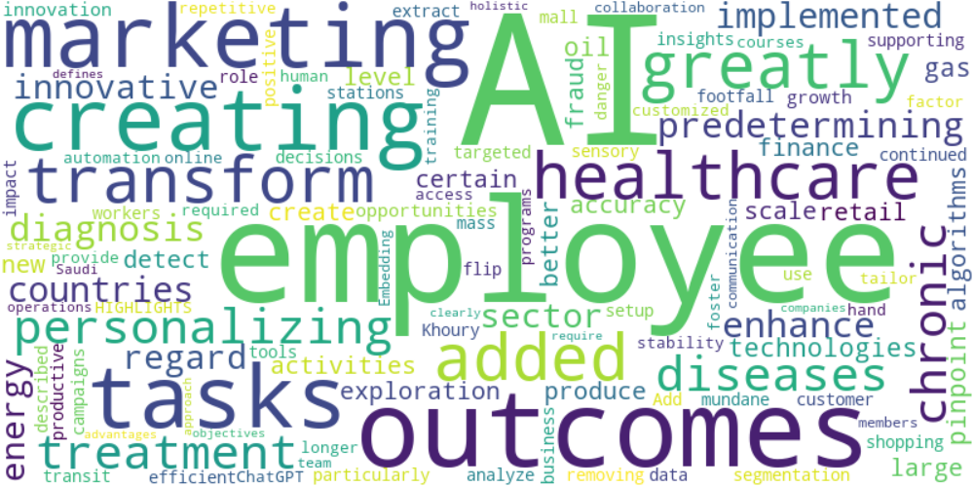

Top 10 words:

- AI: 7

- employees: 3

- outcomes: 2

- marketing: 2

- creating: 2

- tasks: 2

- added: 1

- greatly: 1

- transform: 1

- healthcare: 1

## Wordcloud for #c885da Highlights

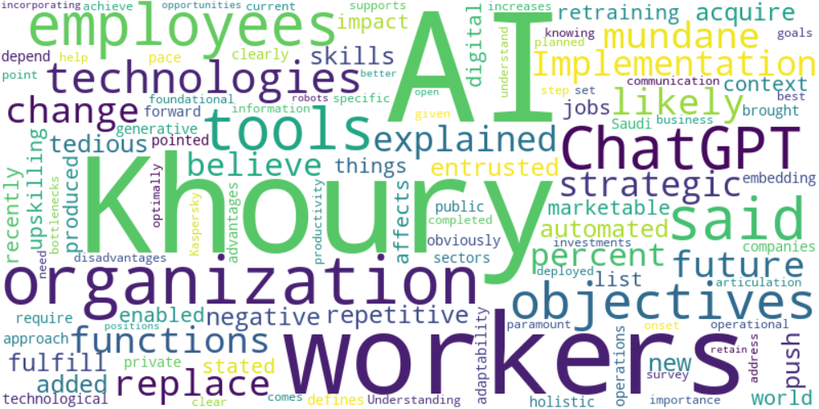

Top 10 words:

- AI: 8

- Khoury: 6

- workers: 4

- ChatGPT: 3

- said: 3

- tools: 3

- employees: 3

- objectives: 3

- organization: 3

- technologies: 3